Case 9-MEX- Nayarit–Ixtlan del Rio-Shaman-Terracotta—200 BCE- 250 CE
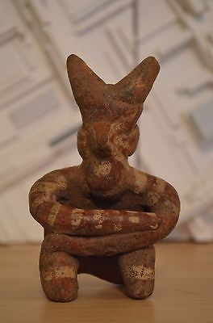
MEX- Nayarit–Ixtlan del Rio-Shaman-Terracotta—200 BCE- 250 CE
Display Description:
The Western Mexico shaft tomb tradition or shaft tomb culture refers to a set of interlocked cultural traits found in the western Mexican states of Jalisco, Nayarit, and, to a lesser extent, Colima to its south. Built beneath house platforms, these tombs served as family mausoleums and were periodically opened to inter the recently deceased. He is wearing a horned cap and his body is painted with kaolin and red ochre for the transformation he is about to enter spiritually.
LC Classification:
Date or Time Horizon: 500 CE
Geographical Area: Nayarit, Mexico
Map:
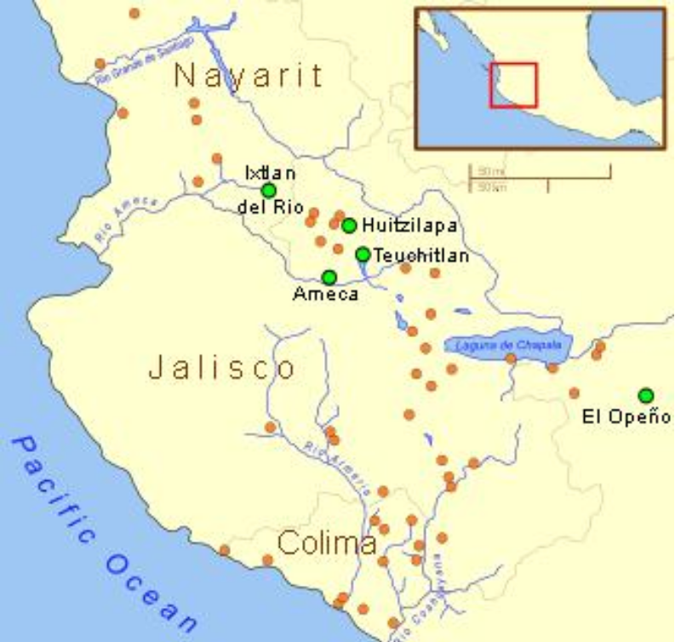Shaft tomb burials in West Mexico. After https://upload.wikimedia.org/wikipedia/commons/thumb/d/d3/Ancient_Western_Mexico_Archaeological_Sites.svg/350px-Ancient_Western_Mexico_Archaeological_Sites.svg.png
GPS coordinates:
Cultural Affiliation:
Media:
Dimensions:
Weight:
Condition:
Provenance:
Discussion:
Shaman from Shaft Tomb near Ixtlan del Rio. The shaman wears a horned helmet, possibly of wood or wicker. His body is colored in kaolin and red ocher.
References:

Kan, Michael, Clement Meighan, H. B. Nicholson. 1989. Sculpture of ancient west Mexico: Nayarit, Jalisco, Colima. A catalogue of the Proctor Stafford Collection at the Los Angeles County Museum of Art. Albuquerque: Los Angeles County Museum of Art in association with

Pre-Columbian Nayarit Mexico Tomb Figure Ixtlan del Rio 200 BC - AD 250
Item price | $100.00
Quantity | 1
Item number | 151878374925
Shipping service | USPS Priority Mail

